DAY 7

CLASS EXERCISE:1

package com.Test.Testing;

import org.junit.Test;

import org.openqa.selenium.WebDriver;

import org.openqa.selenium.chrome.ChromeDriver;

import org.openqa.selenium.chrome.ChromeOptions;

import org.testng.Assert;

import io.github.bonigarcia.wdm.WebDriverManager;

public class AppTest

{

*@*Test

public void AppTitlecheck()

{

ChromeOptions co=new ChromeOptions();

co.addArguments ("--remote-allow-origins=*");

WebDriverManager.chromedriver().setup ();

WebDriver d=new ChromeDriver(co);

d.get("https://demo.wpeverest.com/user-registration/guest-registration-form/");

d.manage().window().maximize();

String actual=d.getTitle();

String expected="Guest Registration Form – User Registration";

Assert.assertEquals(actual, expected);

}

}

OUTPUT:

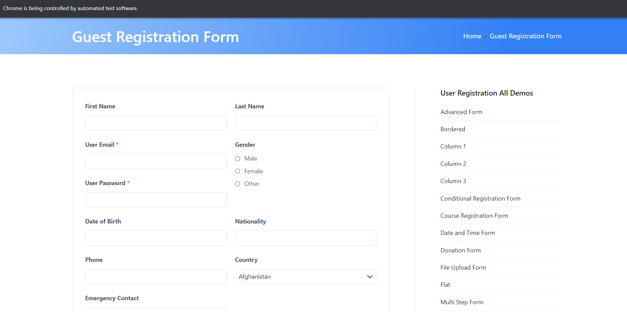

CLASS EXERCISE:2

package com.Test.Testing;

import org.testng.Assert;

import org.testng.annotations.Test;

public class calculate {

*@Test*(priority=1)

public void Div() {

int n1=10;

int n2=30;

int res=n2/n1;

Assert.*assertEquals*(res,3);

}

*@Test*(priority=2)

public void Mul() {

int n1=20;

int n2=30;

int res=n1*n2;

Assert.*assertEquals*(res, 600);

}

*@Test*(priority=3)

public void Sub() {

int n1=50;

int n2=20;

int res=n1-n2;

Assert.*assertEquals*(res,30);

}

*@Test*(priority=4)

public void Add() {

int n1=300;

int n2=215;

int res=n1+n2;

Assert.*assertEquals*(res, 400);

}

}

OUTPUT:

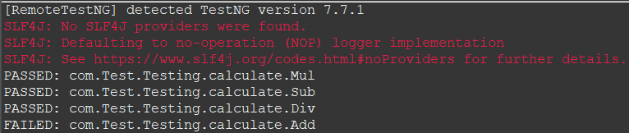

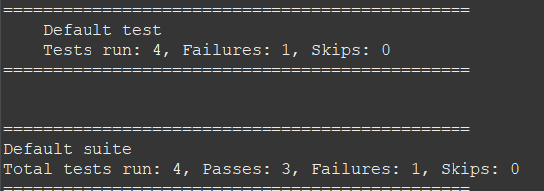

CLASS EXERCISE:3

package com.Test.Testing;

import org.testng.annotations.Test;

import io.github.bonigarcia.wdm.WebDriverManager;

import org.testng.annotations.BeforeMethod;

import org.openqa.selenium.By;

import org.openqa.selenium.WebDriver;

import org.openqa.selenium.chrome.ChromeDriver;

import org.openqa.selenium.chrome.ChromeOptions;

import org.testng.Assert;

import org.testng.annotations.AfterMethod;

public class CE3 {

WebDriver driver;

*@Test*

public void print() throws InterruptedException {

driver.get("https://opensource-demo.orangehrmlive.com/web/index.php/auth/login");

Thread.*sleep*(3000);

driver.findElement(By.*xpath*("//input[@name='username']")).sendKeys("Admin");

driver.findElement(By.*xpath*("//input[@name='password']")).sendKeys("admin123");

driver.findElement(By.*xpath*("//*[@id=\"app\"]/div[1]/div/div[1]/div/div[2]/div[2]/form/div[3]/button")).click();

Thread.*sleep*(3000);

String text=driver.findElement(By.*xpath*("//h6[@class=\'oxd-text oxd-text--h6 oxd-topbar-header-breadcrumb-module\']")).getText();

String expText="Dashboard";

Assert.*assertEquals*(text, expText);

}

*@BeforeMethod*

public void beforeMethod() {

ChromeOptions co=new ChromeOptions();

co.addArguments("--remote-allow-origins=*");

WebDriverManager.*chromedriver*().setup();

driver=new ChromeDriver(co);

}

*@AfterMethod*

public void afterMethod() {

}

}

OUTPUT:

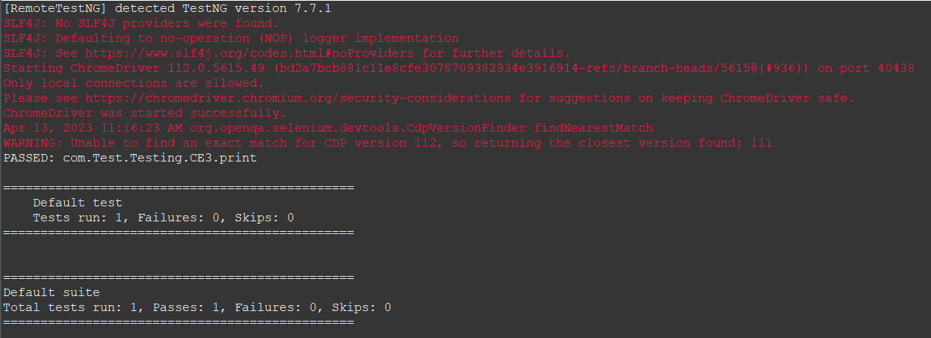

CLASS EXERCISE:4

package com.Test.Testing;

import org.openqa.selenium.By;

import org.openqa.selenium.WebDriver;

import org.openqa.selenium.chrome.ChromeDriver;

import org.openqa.selenium.chrome.ChromeOptions;

import org.testng.Assert;

import org.testng.annotations.Test;

import io.github.bonigarcia.wdm.WebDriverManager;

public class ce4 {

WebDriver d;

*@Test*

public void login() throws InterruptedException {

ChromeOptions co=new ChromeOptions();

co.addArguments("--remote-allow-origins=*");

WebDriverManager.*chromedriver*().setup();

d=new ChromeDriver(co);

d.get("https://opensource-demo.orangehrmlive.com/web/index.php/auth/login");

d.manage().window().maximize();

Thread.*sleep*(2000);

d.findElement(By.*xpath*("//*[@id=\"app\"]/div[1]/div/div[1]/div/div[2]/div[2]/form/div[1]/div/div[2]/input")).sendKeys("Admin");

d.findElement(By.*xpath*("//*[@id=\"app\"]/div[1]/div/div[1]/div/div[2]/div[2]/form/div[2]/div/div[2]/input")).sendKeys("admin123");

d.findElement(By.*xpath*("//*[@id=\"app\"]/div[1]/div/div[1]/div/div[2]/div[2]/form/div[3]/button")).click();

Thread.*sleep*(3000);

String actual="My Actions";

System.***out***.println(actual);

Thread.*sleep*(3000);

String expected=d.findElement(By.*xpath*("//*[@id=\"app\"]/div[1]/div[2]/div[2]/div/div[2]/div/div[1]/div/p")).getText();

Thread.*sleep*(2000);

Assert.*assertEquals*(actual,expected);

System.***out***.println("Logged in");

}

*@Test*

public void logout() throws InterruptedException {

Thread.*sleep*(2000);

d.findElement(By.*xpath*("//*[@id=\"app\"]/div[1]/div[1]/header/div[1]/div[2]/ul/li/span")).click();

d.findElement(By.*xpath*("//*[@id=\"app\"]/div[1]/div[1]/header/div[1]/div[2]/ul/li/ul/li[4]/a")).click();

String txt="Login";

System.***out***.println(txt);

Thread.*sleep*(2000);

String etxt=d.findElement(By.*xpath*("//*[@id=\"app\"]/div[1]/div/div[1]/div/div[2]/h5")).getText();

Assert.*assertEquals*(txt, etxt);

System.***out***.println("Logged out");

}

}

OUTPUT:

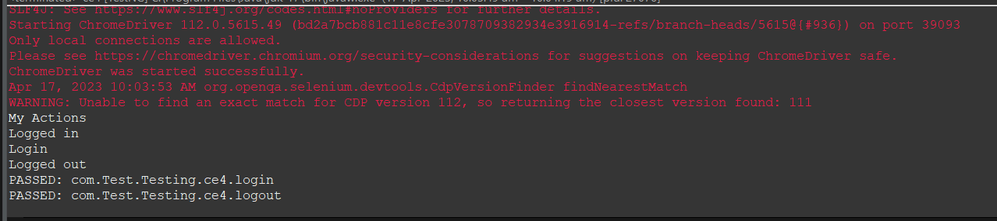

CLASS EXERCISE:5

package com.Test.Testing;

import org.testng.annotations.Test;

import io.github.bonigarcia.wdm.WebDriverManager;

import org.testng.annotations.BeforeMethod;

import java.util.concurrent.TimeUnit;

import org.openqa.selenium.By;

import org.openqa.selenium.WebDriver;

import org.openqa.selenium.chrome.ChromeDriver;

import org.openqa.selenium.chrome.ChromeOptions;

import org.testng.Assert;

import org.testng.annotations.AfterMethod;

public class d75 {

WebDriver d;

*@*Test(groups= {"SmokeTest"})

public void t1() {

String eurl="https://www.godaddy.com/en-in";

String curl=d.getCurrentUrl();

Assert.assertEquals(eurl,curl);

String etitle="Domain Names, Websites, Hosting & Online Marketing Tools - GoDaddy IN";

String ctitle=d.getTitle();

Assert.assertEquals(etitle, ctitle);

}

*@*Test(groups= {"RegressionTest"})

public void t2() {

d.manage().timeouts().implicitlyWait(10,TimeUnit.SECONDS);

d.findElement(By.xpath("//*[@id=\"id-631b049a-e9c0-4d24-8710-c504745206dd\"]/div[2]/div[1]/ul/li[1]/button")).click();

d.findElement(By.xpath("//*[@id=\"id-631b049a-e9c0-4d24-8710-c504745206dd\"]/div[2]/div[1]/ul/li[1]/div/div[2]/div[1]/ul/li[2]/a")).click();

}

*@*Test(groups= {"RegressionTest"})

public void t3() {

d.manage().timeouts().implicitlyWait(10,TimeUnit.SECONDS);

d.findElement(By.xpath("//*[@id=\"id-631b049a-e9c0-4d24-8710-c504745206dd\"]/div[2]/div[1]/ul/li[1]/button")).click();

d.findElement(By.xpath("//*[@id=\"id-631b049a-e9c0-4d24-8710-c504745206dd\"]/div[2]/div[1]/ul/li[1]/div/div[2]/div[1]/ul/li[2]/a")).click();

String et="GoDaddy Domain Search - Buy and Register Available Domain Names";

String ct=d.getTitle();

System.out.println(ct);

Assert.assertEquals(et,ct);

}

*@*BeforeMethod

public void beforeMethod() {

ChromeOptions co=new ChromeOptions();

co.addArguments("--remote-allow-origins=*");

WebDriverManager.chromedriver().setup();

d=new ChromeDriver(co);

d.get("https://www.godaddy.com/en-in");

d.manage().window().maximize();

}

*@*AfterMethod

public void afterMethod() {

d.close();

}

}

OUTPUT:

